USE pubs

--1) Select the author firstname and last name

SELECT au_fname 'First Name', au_lname 'Last Name' FROM authors

ORDER BY 1

SELECT CONCAT(au_fname,' ', au_lname) 'Author Full Name' FROM authors

ORDER BY 1

--2) Sort the titles by the title name in descending order and print all the details

SELECT * FROM titles

ORDER BY title DESC

--3) Print the number of titles published by every author

SELECT TA.au_id 'Author ID', COUNT(T.title) 'No. of Titles'

FROM titles T JOIN titleauthor TA

ON T.title_id = TA.title_id

GROUP BY TA.au_id

--4) print the author name and title name

SELECT CONCAT(A.au_fname,' ', A.au_lname) 'Author Full Name', title 'Title Name'

FROM titles T JOIN titleauthor TA

ON T.title_id = TA.title_id

JOIN authors A ON A.au_id = TA.au_id

ORDER BY 1

--5) print the publisher name and the average advance for every publisher

SELECT P.pub_name 'Publisher Name', AVG(T.advance) 'Average Advance'

FROM publishers P LEFT OUTER JOIN titles T

ON P.pub_id = T.pub_id

GROUP BY P.pub_name

ORDER BY 1

--6) print the publishername, author name, title name and the sale amount(qty*price)

SELECT P.pub_name 'Publisher Name', CONCAT(A.au_fname, ' ', A.au_lname) 'Author Name',

T.title 'Title Name', S.qty*T.price 'Sale Amount'

FROM authors A JOIN titleauthor TA ON A.au_id = TA.au_id

JOIN titles T ON T.title_id = TA.title_id

JOIN publishers P ON P.pub_id = T.pub_id

JOIN sales S ON S.title_id = T.title_id

ORDER BY 1

--7) print the price of all that titles that have name that ends with s

SELECT title 'Title', price 'Price' FROM titles

WHERE title LIKE '%s'

--8) print the title names that contain 'and' in it

SELECT title 'Title' FROM titles

WHERE title LIKE '%and%'

--9) print the employee name and the publisher name

SELECT CONCAT(E.fname, ' ', E.lname) 'Employee Name', P.pub_name 'Publisher Name'

FROM publishers P JOIN employee E

ON P.pub_id = E.pub_id

ORDER BY 2, 1

--10) print the publisher name and number of employees woking in it if the publisher has more than 2 employees

SELECT P.pub_name 'Publisher Name', COUNT(E.pub_id) 'No. of Employee'

FROM publishers P JOIN employee E

ON P.pub_id = E.pub_id

GROUP BY P.pub_name

HAVING COUNT(E.pub_id) > 2

ORDER BY 1

--11) Print the author names who have published using the publisher name 'Algodata Infosystems'

SELECT CONCAT(A.au_fname, ' ', A.au_lname) 'Author Name' FROM authors A

JOIN titleauthor TA ON A.au_id = TA.au_id

JOIN titles T ON T.title_id = TA.title_id

JOIN publishers P ON P.pub_id = T.pub_id

WHERE P.pub_name = 'Algodata Infosystems'

ORDER BY 1

--12) Print the employees of the publisher 'Algodata Infosystems'

SELECT * FROM employee E JOIN publishers P

ON P.pub_id = E.pub_id

WHERE P.pub_name = 'Algodata Infosystems'

ORDER BY 1

--13)Create the following tables

--Employee(id-identity starts in 100 inc by 1, Name,age, phone cannot be null, gender)

--Salary(id-identity starts at 1 increments by 100, Basic,HRA,DA,deductions)

--EmployeeSalary(transaction_number int, employee_id-reference Employee's Id, Salary_id reference Salary Id,Date)

--PS - In the emeployee salary table transaction number is the primary key

--the combination of employee_id, salary_id and date should always be unique

--CREATE DATABASE dbSampleTutorialD3

USE dbSampleTutorialD3

CREATE TABLE Employee(

Emp_id INT IDENTITY(100,1) PRIMARY KEY,

Emp_name VARCHAR(20),

Emp_age INT,

Emp_phone VARCHAR(20) NOT NULL,

Emp_gender VARCHAR(20) CHECK (Emp_gender in ('Male', 'Female', 'Other')))

CREATE TABLE Salary(

Sal_id INT IDENTITY(100,1) PRIMARY KEY,

Sal_basic FLOAT,

Sal_HRA FLOAT,

Sal_DA FLOAT,

Sal_deductions FLOAT)

CREATE TABLE EmployeeSalary(

Tran_num INT IDENTITY(1,1) PRIMARY KEY,

Emp_id INT CONSTRAINT fk_empId FOREIGN KEY REFERENCES Employee(Emp_id),

Sal_id INT CONSTRAINT fk_salId FOREIGN KEY REFERENCES Salary(Sal_id),

Tran_date DATE,

UNIQUE (Emp_id, Sal_id, Tran_date)

)

--Add a column email-varchar(100) to the employee table

ALTER TABLE Employee ADD Emp_email VARCHAR(100)

--Insert few records in all the tables

INSERT INTO Employee VALUES('Aria', 20, '0123456789', 'Female', 'aria20@email.com')

INSERT INTO Employee VALUES('Bob', 22, '0113456789', 'Male', 'bob22@email.com')

INSERT INTO Employee VALUES('Carson', 22, '0111456789', 'Other', 'iamacar@email.com')

INSERT INTO Salary VALUES(5000,1000,1500,500)

INSERT INTO Salary VALUES(15000,400,600,550)

INSERT INTO Salary VALUES(10000,500,1000,50)

INSERT INTO EmployeeSalary VALUES(100,100,'2021-10-01')

INSERT INTO EmployeeSalary VALUES(101,101,'2021-10-02')

INSERT INTO EmployeeSalary VALUES(102,102,'2021-10-03')

INSERT INTO EmployeeSalary VALUES(100,102,'2021-10-04')

--Create a procedure which will print the total salary of employee by taking the employee id and the date

--total = Basic+HRA+DA-deductions

CREATE PROC sp_totalEmpSalary(

@Emp_id INT,

@date DATE

)

AS

BEGIN

DECLARE

@Sal_id INT,

@basic FLOAT,

@HRA FLOAT,

@DA FLOAT,

@deductios FLOAT,

@totalSal FLOAT

SET @Sal_id = (SELECT Sal_id FROM EmployeeSalary WHERE Emp_id = @Emp_id AND Tran_date = @date)

SET @basic = (SELECT Sal_basic FROM Salary WHERE Sal_id = @Sal_id)

SET @HRA = (SELECT Sal_HRA FROM Salary WHERE Sal_id = @Sal_id)

SET @DA = (SELECT Sal_DA FROM Salary WHERE Sal_id = @Sal_id)

SET @deductios = (SELECT Sal_deductions FROM Salary WHERE Sal_id = @Sal_id)

SET @totalSal = @basic + @HRA + @DA - @deductios

PRINT 'Total Salary of Employee ID: ' + CAST(@Emp_id AS VARCHAR(20)) + ' is ' + CAST(@totalSal AS VARCHAR(20))

END

--Create a procedure which will calculate the average salary of an employee taking his ID

CREATE PROC sp_averageEmpSalary(

@Emp_id INT

)

AS

BEGIN

DECLARE

@Sal_count INT,

@Sal_id INT,

@basic FLOAT,

@HRA FLOAT,

@DA FLOAT,

@deductios FLOAT,

@totalSal FLOAT,

@averageSAL FLOAT

SET @Sal_count = (SELECT COUNT(Sal_id) FROM EmployeeSalary WHERE Sal_id IN (SELECT Sal_id FROM EmployeeSalary WHERE Emp_id = @Emp_id))

IF (@Sal_count > 1)

BEGIN

SET @basic = (SELECT SUM(Sal_basic) FROM Salary WHERE Sal_id IN (SELECT Sal_id FROM EmployeeSalary WHERE Emp_id = @Emp_id))

SET @HRA = (SELECT SUM(Sal_HRA) FROM Salary WHERE Sal_id IN (SELECT Sal_id FROM EmployeeSalary WHERE Emp_id = @Emp_id))

SET @DA = (SELECT SUM(Sal_DA) FROM Salary WHERE Sal_id IN (SELECT Sal_id FROM EmployeeSalary WHERE Emp_id = @Emp_id))

SET @deductios = (SELECT SUM(Sal_deductions) FROM Salary WHERE Sal_id IN (SELECT Sal_id FROM EmployeeSalary WHERE Emp_id = @Emp_id))

SET @totalSal = @basic + @HRA + @DA - @deductios

SET @averageSAL = @totalSal / @Sal_count

END

ELSE

BEGIN

SET @Sal_id = (SELECT Sal_id FROM EmployeeSalary WHERE Emp_id = @Emp_id)

SET @basic = (SELECT Sal_basic FROM Salary WHERE Sal_id = @Sal_id)

SET @HRA = (SELECT Sal_HRA FROM Salary WHERE Sal_id = @Sal_id)

SET @DA = (SELECT Sal_DA FROM Salary WHERE Sal_id = @Sal_id)

SET @deductios = (SELECT Sal_deductions FROM Salary WHERE Sal_id = @Sal_id)

SET @totalSal = @basic + @HRA + @DA - @deductios

SET @averageSAL = @totalSal

END

PRINT 'Average Salary of Employee ID: ' + CAST(@Emp_id AS VARCHAR(20)) + ' is ' + CAST(@averageSAL AS VARCHAR(20))

END

--Create a procedure which will catculate tax payable by employee

--Slabs as follows

--total < 100000 - 0%

--100000 < total < 200000 - 5%

--200000 < total < 350000 - 6%

--total > 350000 - 7.5%

CREATE PROC sp_calculateTaxPay(

@Emp_id INT)

AS

BEGIN

DECLARE

@Sal_count INT,

@Sal_id INT,

@basic FLOAT,

@HRA FLOAT,

@DA FLOAT,

@deductios FLOAT,

@totalSal FLOAT,

@taxPay FLOAT

SET @basic = (SELECT SUM(Sal_basic) FROM Salary WHERE Sal_id IN (SELECT Sal_id FROM EmployeeSalary WHERE Emp_id = @Emp_id))

SET @HRA = (SELECT SUM(Sal_HRA) FROM Salary WHERE Sal_id IN (SELECT Sal_id FROM EmployeeSalary WHERE Emp_id = @Emp_id))

SET @DA = (SELECT SUM(Sal_DA) FROM Salary WHERE Sal_id IN (SELECT Sal_id FROM EmployeeSalary WHERE Emp_id = @Emp_id))

SET @deductios = (SELECT SUM(Sal_deductions) FROM Salary WHERE Sal_id IN (SELECT Sal_id FROM EmployeeSalary WHERE Emp_id = @Emp_id))

SET @totalSal = @basic + @HRA + @DA - @deductios

IF (@totalSal < 10000) -- 0%

BEGIN

SET @taxPay = 0

END

ELSE IF (@totalSal >10000 AND @totalSal < 20000) -- 5%

BEGIN

SET @taxPay = 0.05*@totalSal

END

ELSE IF (@totalSal >200000 AND @totalSal <350000) -- 6%

BEGIN

SET @taxPay = 0.06*@totalSal

END

ELSE IF (@totalSal >350000) -- 7.5%

BEGIN

SET @taxPay = 0.075*@totalSal

END

PRINT 'The Tax payable for the Employee ID: ' + CAST(@Emp_id AS VARCHAR(20)) + ' is ' + CAST(@taxPay AS VARCHAR(20))

END

--testing execution

EXEC sp_totalEmpSalary 100, '2021-10-01'

EXEC sp_averageEmpSalary 100

EXEC sp_calculateTaxPay 100

--14) Create a function that will take the basic,HRA and da returns the sum of the three

CREATE FUNCTION fn_sumOfThree(

@basic FLOAT,

@da FLOAT,

@hra FLOAT)

RETURNS FLOAT

AS

BEGIN

RETURN @basic + @da + @hra

END

SELECT dbo.fn_sumOfThree(10,10,10)

--15) Create a cursor that will pick up every employee and print his details

--then print all the entries for his salary in the employeesalary table.

--Also show the salary splitt up(Hint-> use the salary table)

DECLARE

@Empl_id INT ,

@Empl_name VARCHAR(20),

@Empl_age INT,

@Empl_phone VARCHAR(20),

@Empl_gender VARCHAR(20),

@Empl_email VARCHAR(100)

DECLARE cur_employee CURSOR FOR SELECT * FROM Employee

OPEN cur_employee

FETCH NEXT FROM cur_employee INTO @Empl_id, @Empl_name, @Empl_age , @Empl_phone , @Empl_gender, @Empl_email

WHILE (@@FETCH_STATUS = 0)

BEGIN

PRINT 'Employee number: ' + CAST(@Empl_id AS VARCHAR(20))

PRINT 'Employee name: ' + CAST(@Empl_name AS VARCHAR(20))

PRINT 'Employee age: ' + CAST(@Empl_age AS VARCHAR(20))

PRINT 'Employee phone: ' + CAST(@Empl_phone AS VARCHAR(20))

PRINT 'Employee gender: ' + CAST(@Empl_gender AS VARCHAR(20))

PRINT 'Employee email: ' + CAST(@Empl_email AS VARCHAR(20))

PRINT '-----------------------------------------------------------'

DECLARE

@ES_num INT,

@ES_emp_id INT,

@ES_sal_id INT,

@ES_date DATE

DECLARE cur_empSalary CURSOR FOR SELECT Tran_num, Sal_id, Tran_date FROM EmployeeSalary WHERE Emp_id = @Empl_id

OPEN cur_empSalary

FETCH NEXT FROM cur_empSalary INTO @ES_num ,@ES_sal_id ,@ES_date

WHILE (@@FETCH_STATUS = 0)

BEGIN

PRINT ' Transaction number: ' + CAST(@ES_num AS VARCHAR(20))

PRINT ' Salary ID: ' + CAST(@ES_sal_id AS VARCHAR(20))

PRINT ' Transaction date: ' + CAST(@ES_date AS VARCHAR(20))

PRINT '-----------------------------------------------------------'

DECLARE

@Sala_basic FLOAT,

@Sala_HRA FLOAT,

@Sala_DA FLOAT,

@Sala_deductions FLOAT

DECLARE cur_salary CURSOR FOR SELECT Sal_basic, Sal_HRA, Sal_DA, Sal_deductions FROM Salary WHERE Sal_id = @ES_sal_id

OPEN cur_salary

FETCH NEXT FROM cur_salary INTO @Sala_basic ,@Sala_HRA ,@Sala_DA, @Sala_deductions

WHILE (@@FETCH_STATUS = 0)

BEGIN

PRINT ' Basic Salary: ' + CAST(@Sala_basic AS VARCHAR(20))

PRINT ' HRA: ' + CAST(@Sala_HRA AS VARCHAR(20))

PRINT ' DA: ' + CAST(@Sala_DA AS VARCHAR(20))

PRINT ' Deductions: ' + CAST(@Sala_deductions AS VARCHAR(20))

PRINT '-----------------------------------------------------------'

FETCH NEXT FROM cur_salary INTO @Sala_basic ,@Sala_HRA ,@Sala_DA, @Sala_deductions

END

CLOSE cur_salary

DEALLOCATE cur_salary

FETCH NEXT FROM cur_empSalary INTO @ES_num,@ES_sal_id ,@ES_date

END

CLOSE cur_empSalary

DEALLOCATE cur_empSalary

FETCH NEXT FROM cur_employee INTO @Empl_id, @Empl_name, @Empl_age , @Empl_phone , @Empl_gender, @Empl_email

END

CLOSE cur_employee

DEALLOCATE cur_employee

**Output:**

Question 1:

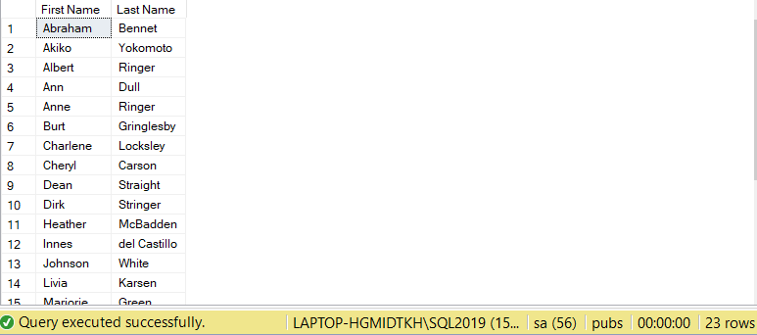

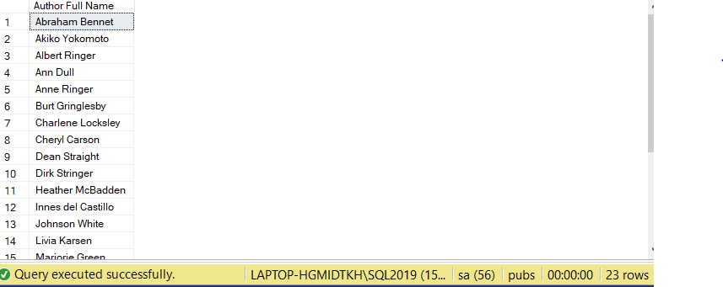

Question 2:

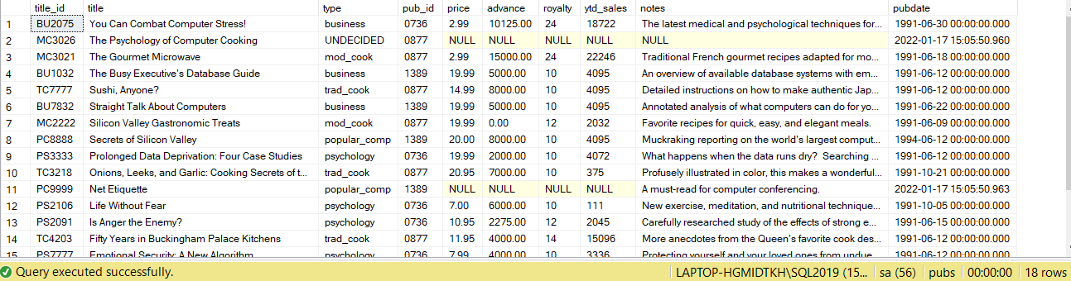

Question 3:

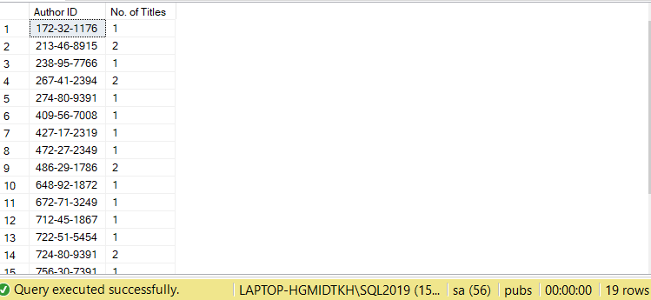

Question 4:

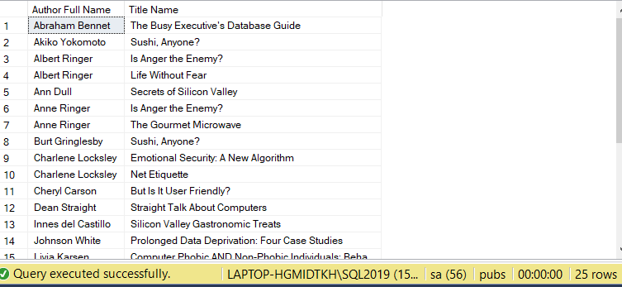

Question 5:

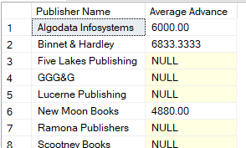

Question 6:

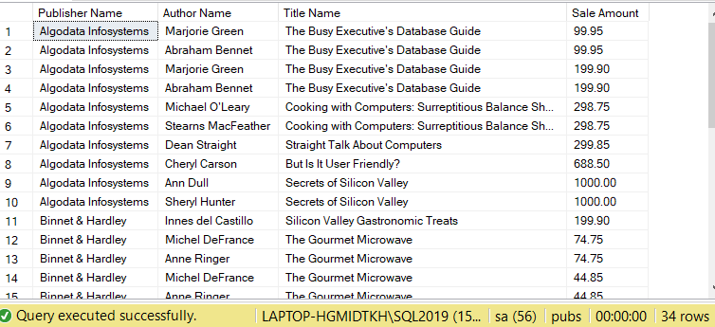

Question 7:

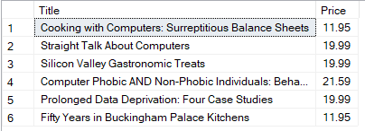

Question 8:



Question 9:

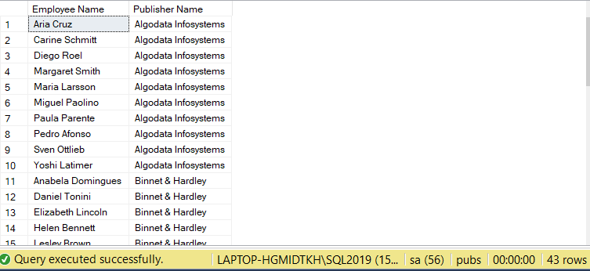

Question 10:

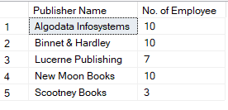

Question 11:

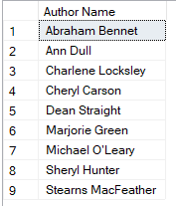

Question 12:

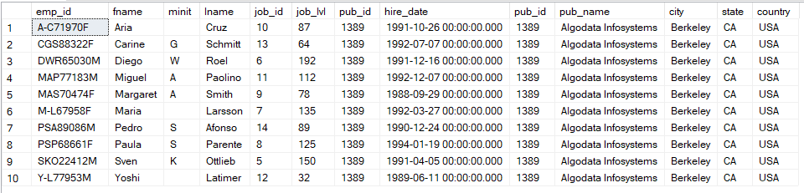

Question 13:

SELECT * FROM Employee

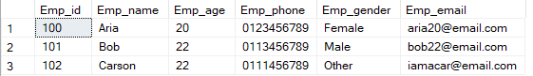

SELECT * FROM EmployeeSalary

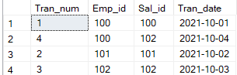

SELECT * FROM Salary

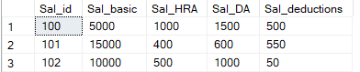

EXEC sp_totalEmpSalary 100, '2021-10-01'



EXEC sp_averageEmpSalary 100

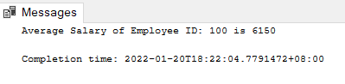

EXEC sp_calculateTaxPay 100

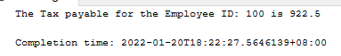

Question 14:

SELECT dbo.fn_sumOfThree(10,10,10)



Question 15:

